Change Request
Subject | Bank Transfer Tickets
Requester | Wafaa Abdelaziz
Requester Department | Enterprise
Ref. Project Name
Ref. Project Manager | Nada Mohammed
Submission Date | 31-7-2022
Received By | Nada Mohammed

Change Main Info

Application Name: E-Ticketing
Module Name: Bank Transfer Tickets
Screen/Report Name:
Change Type: (put a mark beside the changes types)
 | Bug |  | Appearance modification |  | Business logic modification
 | add new fields |  | add new reports |  | add new screens
 | add new modules |  | other

Amendment History
Version | Issue Date | Author(s) of changes | Details of Changes made
0.1 | 31-7-2022 | Nada Mohammed | Initial CR Document

Description

Current Behavior:

Currently the bank transfer process is handled via mail between collection, bank relation and cash operation teams

Desired Behavior:
Reference the Bank Transfer tickets project the below modification is required while creation & in Bank relation cycle

Analysis Feedback

- Tickets Creation will only be available for Credit & collection Team & debit recovery team “users attached”
- After creation Ticket will be transferred with status open based on the transaction type:
  - Bank Transfer & Cash deposit to “bank transfer” pool.
  - Collection Cheque to “collection cheque” pool.
- when the ticket is confirmed from Bank transfer/ collection cheque agent, he will transfer the ticket to Bank transfer/ collection cheque super.
- If the ticket is rejected from Bank transfer/ collection cheque agent it will be transferred to the creator pool credit & colletion or debit recovery.
- If the agent chooses ticket status pending, it will remain in the same pool “Bank transfer/ collection cheque”
- If the ticket in Bank transfer/ collection cheque Super status is Approved user will transfer it to cash operation team.
- If the ticket in Bank transfer/ collection cheque Super status is Disapproved ticket will return automatically to same (Bank transfer/ collection cheque) user who transferred the ticket.
- Once ticket is returned to credit & collection/ debit recovery team with status rejected all fields will be open and editable again (update view).
- After updating the ticket from credit & collection/ debit recovery team user will transfer it again to bank relation department to start the cycle again.

Fulfilment Work Flow:
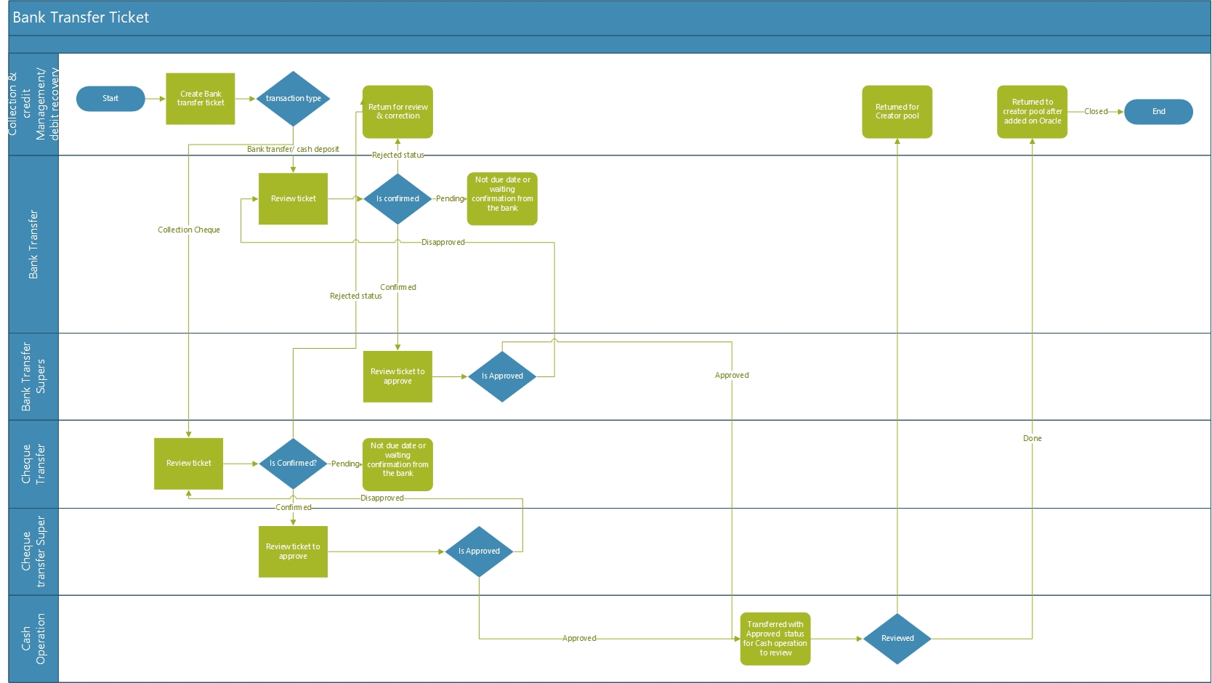

References, supporting docs and approvals:

